How does political finance legislation influence control of corruption?

Improving good governance in Latin America

Alvaro Lopez, Mario Rodriguez and Mariano Valentini

1. Introduction 3

2. Literature Review 4

From Corruption to Control of Corruption 4

Definition of Political Finance 7

The Link Between Political Finance And Corruption 8

Political Finance And Corruption In Latin America 15

Public Expenditure and its Relation with Corruption 17

Judicial Independence: A Precondition for Control of Corruption? 18

3. Methodology 19

Results 22

Descriptive statistics world panel dataset 22

Political Finance Regulation and Control of Corruption in Latin America 25

Panel regression model of Latin America 29

Variable description 29

Simple regression model 30

Multivariate regression model 30

Marginal effects 32

References 34

# 1. Introduction

The corruption of political parties is one of the most critical issues for democracies, especially young ones. On one hand, corrupt parties can seriously damage democracy by undermining public trust, increasing voters’ disillusionment and even leading to authoritarian regimes. On the other hand, honest parties play a vital role within democracies, since they are the bridge between people and their governments. (Blechinger 2002, p. 4)

Today, a relative majority of countries are organized around regular elections and people are involved in public affairs more than ever before. Yet, corruption is expanding among new democracies and not decreasing, contrary to common sense. (Mungiu-Pippidi 2015, p. 2)

Latin America is the perfect example of this situation. Even though in the last decades, democracies in the region experienced an important consolidation, corruption scandals related to the influence of money in politics did not stop. Actually, issues like the illicit funding of candidates and parties by criminal organizations, as well as the misuse of public resources by parties in government, have gained weight in the public agenda.

Therefore, how to control corruption within the realm of political finance in Latin America is the central question we will seek to answer through this thesis. Mainly, we will concentrate our efforts in analysing one of the most common tools broadly suggested when it comes about political corruption: *political finance regulation*. Developing an index with the biggest database worldwide about this topic, our main goal will be to identify how the different levels and types of party finance regulation interact with control of corruption in the world, although we will take an special focus in Latin America.

Furthermore, the most recent literature states that political corruption is a multidimensional problem, so control of corruption is presented as an equilibrium model. In addition to party finance regulation, we will also focus on a variable normally utilized as a way to measure opportunities for corruption: *public spending discretion*. Using data from capital expenditures among the Latin American States, we will analyse how control of corruption in Latin America interacts with both; political finance regulation and discretionary public spending.

As we anticipated, our main goal will be to develop clear proposals about how to tackle political corruption in Latin America. Party finance regulation will be the main field of enquiry, while discretionary public spending will be a supporting variable to elaborate conclusions based on an equilibrium model of control of corruption.

# 2. Literature Review

## From Corruption to Control of Corruption

Corruption is not harmless and has indisputable negative consequences for societies. For example, corruption leads to massive brain drain and produces disincentives for hard working and integrity. It also affects fair competition and gender equality, in addition to distorting public spending and equal access to public jobs. (Mungiu-Pippidi 2015, p. 2)

Notwithstanding the importance of the concept, the definition of corruption represents a challenge. According to Mungiu-Pippidi (2015, p. 3), there seems to be an agreement around the idea that “corruption involves some undue private profit (for someone) due to the abuse of an entrusted public authority”.

Indeed, since 2005, the United Nations Convention Against Corruption (UNCAC) provided a frame of the idea of corruption, supported by its 181 Parties. Despite the fact that this international instrument does not offer a clear definition of corruption, the Convention states in its first article that one of its purposes is “[t]o promote integrity, accountability and proper management of public affairs and public property.” (UNCAC, Art. 1.c) Moreover, the first preventive measure of the Convention states that: “Each State Party shall, in accordance with the fundamental principles of its legal system, develop and implement or maintain effective, coordinated anti-corruption policies that promote the participation of society and reflect the principles of the rule of law, proper management of public affairs and public property, integrity, transparency and accountability.” (UNCAC, Art. 5.1)

According to Mungiu-Pippidi (2015, p. 11), the classic definition of corruption made by Nye in 1967, as a “behaviour which deviates from the formal duties of a public role because of private-regarding (personal, close family, private clique) pecuniary or status gains; or violates rules against the exercise of certain types of private-regarding influence)” highlights the connection between the public and the private spheres. However, this definition does not consider situations where “laws and policies themselves are corrupt and seek to create legal privileges for those connected with the source of authority granting the privilege”.

Furthermore, there are three main characteristics of the idea of corruption. First, fraudulent behaviours between private actors are normally defined as “fraud”, staying out the realm of corruption. Second, the notion of “abuse of public authority” instead of “public interest” or “public trust”, is assumed to avoid cases where public interests or trust can be damaged by private parties, like a referee in a soccer game. Third, corruption exceeds the notion of “deviation from the norm”, since the idea of “public interest” of this definition implies a high level of relativism and has mutated over the years and cultures. (Mungiu-Pippidi 2015, p. 12)

Based on these characteristics and on the different kinds of principles that predominantly rule societies -patrimonialism, particularism and/or ethical universalism-, Mungiu-Pippidi (2015, p. 15) notes that agreeing on a unique and universal definition of corruption is complicated, since it is a phenomenon affected by many disciplines.

Indeed, she highlights that in societies where ethical universalism –equal treatment of all the members of a society by the government when implementing laws and policies– has not been achieved, the different kinds of corruption can be immeasurable, due to the perpetuation of groups taking advantage of public resources. (Mungiu-Pippidi 2015, p. 17)

In a theoretical-practical approach, the author turns the focus from idea of “corruption” to the notion of “control of corruption”, defined as “a given society´s capacity to constrain the use of public authority to generate private rents detrimental to overall social welfare”. (Mungiu Pippidi 2015, p. 18)

Then, the key question is how a certain society can constrain the missuses of public resources by an individual or a group in their own and private benefit, and guarantee that the state serves to the social wellbeing. Thus, Mungiu-Pippidi (2015, p. 19) addresses the issue of “corruption”, not from an individual perspective, but from a societal one. The difference is that while the former would be aimed at the undue profits made by individuals due to the abuse of public authority, the latter sees corruption “as an intrinsic part of certain governance context, a social allocation mode”.

This approach exceeds the notion of corruption as a simple aggregation of individual corrupt acts. Conversely, it is focused on how the work of institutions and the rules of game determine the allocation of public resources. Mungiu-Pippidi (2015, p. 23) highlights that countries with the highest levels of control of corruption, at some point in their histories, managed to institutionalize open and non-discriminative access to their institutions.

Indeed, “human agency” is indispensable to make progress in governance. It means to move from “particularistic” societies where states and their institutions are used as instruments for particular private profits, to more “ethical universalistic” societies where institutions seek out the general welfare. (Mungiu-Pippidi 2015, p. 82)

However, when it comes to the question about the right kind of human agency, the answer tends to be contested. Implementing anticorruption laws, liberalizing trade, increasing accountability, are just some of the options normally analysed.

Actually, the answer will depend on the type of “control of corruption model” we choose. Mungiu-Pippidi differentiates between three main models of control of corruption. The first one is based on structural factors. Traditional factors, like trust, natural resources, and/or geographical and living conditions, as well as modernization conditions like literacy rates, urbanization and life expectancy. The second model, aimed at the promotion of anti-corruption legislation and the adoption of some anticorruption tools for domestic implementation, such as; civil service merit-based recruitment, administrative reforms and independent control agencies, which can include freedom of information legislation, anticorruption agencies and ombudspersons. Finally, a third model of control of corruption is identified: the equilibrium model. Based on the understanding of corruption as equilibrium between costs and benefits pioneered by Klitgaard (1988) and Huther and Shah (2000), Mungiu-Pippidi (2015, p. 116) states that “the ideal model to explain control of corruption should be an equilibrium model without a principal-agent perspective”, in order to overcome those situations where principals are the ones to be enforced.

The equilibrium model understands control of corruption as the balance between opportunities or resources to corrupt and the deterrents or constraints imposed by the society as a whole. Indeed, this approach is aimed at the collective capacity to enforce good governance, which means, the capacity of a society to reduce particularistic situations and increase ethical universalism among their institutions. (Mungiu-Pippidi 2015, p. 116)

Then, the equilibrium model formula of control of corruption developed by Mungiu-Pippidi (2015, p. 117) is:

“*Control of corruption= Constraints (Legal+Normative) – Opportunities (Power Discretion + Material Resources)”*.

Based on this model, in our thesis we will seek to address a central issue of particularistic societies and corruption. When ethical universalism is not the norm, private entities usually make “favours” to political parties and/or political candidates in order to be reciprocated once that party/person is in charge of public resources. (Mungiu-Pippidi 2015, p. 16)

For the last decades, scholars have been analysing a significant dimension of control of corruption related to this problem: *political finance regulation*. However, it seems that there is not an overall agreement on the advantages of this approach when it comes to decrease corruption. While some specialists and international organisations encourage states to adopt broader regulatory framework, some research argues that those regulations are useless, since they cannot prevent money influences over politics effectively.

The discussion regarding political finance regulation can be tackled from diverse theoretical angles and from different regional perspectives. In our thesis, we will focus our efforts to understand how political finance regulations have influenced control of corruption, specifically in Latin America. In other words, we will seek to identify if political finance regulation has been an effective constraint to particularism in Latin America.

## Definition of Political Finance

To define the other main concept of this thesis, we will follow the guidelines provided by the International Institute for Democracy and Electoral Assistance (IDEA), which developed the most complete database about political finance regulation in the world. Even though political finance usually refers to all the money flowing all over the political process, we will focus on those issues “most closely related to the process of electoral democracy”, sticking to the definition of political finance as “the (legal and illegal) financing of ongoing political party activities and electoral campaigns (in particular, campaigns by candidates and political parties, but also by third parties).” (IDEA 2014, p. 2)

Internal political parties’ behaviour, availability of state resources and private founders´ activities, are some of the elements that comprise the realm of political finance. Regulation of at least some of these matters has been adopted by most of states in the last decades. Political finance regulation, then, looks to prevent the missuses of money in politics, as well as to provide the necessary framework to enforce some mandates and sanction those who violates them. (IDEA 2014, p. 2)

Indeed, political finance regulation is seen as a key variable of more transparent and legitimate democracies. The need to regulate money in politics is usually considered as an indispensable step to diminish the unequal influences of big donors over candidates and parties. The Global Commission on Elections, Democracy and Security, for instance, stated that "the failure to regulate political finance threatens to hollow out democracy and rob it of its unique strengths". (Kofi A. Annan 2014, p. IV IDEA Report)

The lack of political finance regulation has been identified as an opportunity for organized crime to influence politics and as a cause of negative economic development. Former UN Secretary General Kofi Annan called for a better control of political finance, meaning that governments should regulate donations and expenditures effectively, increase transparency of donations, require disclosure of financial sources, adopt sanctions for non-compliance and legislate over effective monitoring and enforcement mechanisms. (Kofi A. Annan 2014, p. IV IDEA Report)

However, there seems to be a general agreement on the conviction that more regulation does not necessarily mean neither more transparency, nor a better balance of power between those with money and people in general. Indeed, IDEA concludes that in some situations, depending on the social-political context and/or the aims of the regulation, a high level of regulation may be not desirable. (IDEA 2014, p. 4)

All in all, this shows an open discussion about the capacity of political finance regulation to influence control of corruption within states. Does, actually, political finance regulation reduce corruption? Are there certain types of regulations more effective than others when it comes about corruption? Does political finance regulation generate rent-seeking contexts?

## The Link Between Political Finance And Corruption

The scholar debate about political finance can be traced back decades. The issue was discussed in the 1940s, when specialists could not reach an agreement on how to address limitations to contributions and expenditures of candidates and parties over electoral campaigns in the US. (Overacker 1941)

To tackle the problem of the "power of the purse" for the presidential campaign in 1940, the US Congress decided to increase party finance regulations. There were already some limitations to the amount of contributions and total expenditures of candidates and parties since 1911. Nevertheless, through the "Hatch Act II", Congress also limited the amount of money that an individual could contribute to a national committee and the level of expenditures permitted to these agencies. (Overacker 1941)

The results of the new legal framework were poor. Its subjects adopted deliberated strategies to circumvent the goal of the law without violating its letter; both major US parties decentralized the collection and distribution of funds. Indeed, Overacker concluded that the endeavour to regulate camping funds was "ambiguous, unworkable, and conducive to unhealthy political practices". Based on the evidence, Overacker disputed the advice from other specialists who were in favour of more party finance regulation. Conversely, she supported the idea of increasing the publicity of party funding instead of passing new legal prohibitions. (Overacker 1941)

At the beginning of the 1960s, in a publication that was said to be "the starting point of the new subject [party finance]" (Blondel 1970), Heidenheimer went a step further in comparing political finance processes. After recognizing that a high quality comparative study on the topic would require greater amounts of data and more unified concepts, he looked to develop an initial comparative evaluation of data and information. At that time, Heidenheimer observed in the literature on parties, two main polar models in terms of party finance processes. The first built around mass parties and based on memberships’ dues paying. The second concerning cadre party, who’s financing relied upon the "whim of a few hidden large-scale contributors and ´interests´". (Heidenheimer 1963)

He stated that in the 1960s most Western parties were turning into mass parties and had started to diversify their sources of financial support, affecting financing patterns. Indeed, throughout his work, Heidenheimer compared party finance processes to identify the existence of a historical evolution. He touched upon the issue of regulation within this realm, but only accessorily. He observed that only a small amount of countries tried to prohibit corporate political donations like the US. Indeed, Heidenheimer concluded that there were tax laws on different countries that had considerable influence on the issue. He mentioned that donations limits stuck to profits and tax-deduction mechanisms are the ruling way of party finance. However, he admitted that the application of these regulations deserved much more detailed studies on a comparative level. (Heidenheimer 1963)

Over the 1960s some scholars observed a growing tendency among Western countries regarding party finance. They saw that in a number of countries, political parties were abandoning their traditional sources of income from the 19th and 20th centuries and changed towards a public subsidized system. (Blondel 1970, preface)

Concerned about this phenomenon, scholars started to analyse the importance and effectiveness of party finance over electoral results, mainly focusing on the relationship between economic and political powers. Consequently, they went into the realm of party finance regulation. (Heidenheimer 1970)

Taking into account Max Weber´s assertion about how party finance defines the way in which influence spreads over the political system, Heidenheimer studied the different practices and experiences related to the rising spending and controlling of political funds. Regarding the latter, the scholar pointed out different regulations related to campaign expenditures, like spending limits and expenditures reporting requirements. (Heidenheimer 1970)

Moreover, he underlined the political discussion about Parties Law in Germany. Specifically, when the proposal of prohibiting corporate donations to parties and candidates was criticised on the basis of the American experience, which proved that such rules could be easily circumvented. Nevertheless, Heidenheimer observed a high correlation between the enforcement level of expenditures disclosure and the degree of public access to that information. (Heidenheimer 1970)

In the 21th century, still interested in the structure of modern mass parties, Heidenheimer turned his focus over to the relationship between party finance processes and political corruption. He argues that despite the creation of the Party Finance and Political Corruption of the International Political Science Association on the 1960s, for many decades there was a lack of studies that analyse “linkages between party finance processes and explicitly recognized patterns of political corruption”. The main reason is the differences in prevailing national ideas of political corruption. (Heidenheimer 2007, p. 764)

After relating a party and campaign expenditure index from the early 1960s and the corruption perception index from 1995-1997, Heidenheimer found a pretty consistent relationship between both rankings. His study covered nine different countries and, taking into account the 30 years gap between both indexes, he concluded that higher campaign expenditure increased corruption. (Heidenheimer 2007, p. 772)

According to Mauro, government regulations are a key element for corruption. Based on economic research, he states that corruption takes place where rents exist, and since public regulations usually provide discretion to public officials, government restrictions tend to result in rent-seeking behaviour, like in the case of import quotas. (Mauro 1998)

He mentions different situations where government restrictions generate excessive profits increasing corruption likability. Examples are trade constraints, favourite industrial policies, price controls, multiple exchange rate policies, foreign exchange allocation schemes and provision of credit under governmental control. Also, he underlines rent-seeking contexts in the absence of governmental intervention, like the case of natural resources, which generate extraordinary profits, and therefore, increase the incentives to bribe those who allocate extraction rights. (Mauro 1998)

Despite the depth of his analysis, Mauro does not mention party finance regulation as a cause of corruption. The fact that this kind of rules seek to restrict politicians instead of empower them may be a central difference with regulations that enable rent-seeking scenarios. Party finance regulation is not mentioned as a tool to fight corruption, at least, in a direct way. Among the different options analysed by the author to reduce corruption, the need of transparency is recurrent; budget transparency, as well as, government expenditures transparency are hopeful alternatives. (Mauro 1998) So, depending on how we define party finance regulation, as a rent-seeking generator or a transparency tool, our object of study can be considered as a corruption promoter or a corruption fighter.

According to Wilcox, there seems to be a general agreement around the positive effects of disclosure within the campaign finance system in the US. Indeed, the obligation that candidates, political parties and interest groups reveal their funding sources and how they expend money tend to be accepted as a way to reduce corruption among campaign systems. (Wilcox 2001, p.2)

Disclosure regulation has advantages and disadvantages. Among the first group, the improvement of corruption control and civic accountability stand out. On the other hand, overexposure of private donors, small parties’ under-funding and rent-seeking, are mentioned as possible costs. (Wilcox 2001, p. 38)

Studying the US experience, Wilcox concludes that a good disclosure system would need to define "campaign activity" broadly in order to avoid circumventions of the rules. It also has to provide the policymaking authority with the ability to adapt to different practices. However, it is important to balance the costs and benefits of the disclosure system, considering the social and political context. (Wilcox 2001, p. 38)

Based on different study cases, Blechinger concludes that party finance regulation, mainly aimed at campaign finance, as well as intra- and external party anti-corruption laws, is important. Nevertheless, to be effective it needs to be part of a broader strategy that includes party competition -internally and externally-, more transparency, monitoring activities in charge of free media, active civil society and up-to-date citizenry. (Blechinger 2002, p. 2)

On the subject of parties, Hopkin (2004) argues that following the decline in party membership, partially caused by scandals that feed the perception of politicians as corrupt, there has been changes in patterns of party finance, specifically a shift from the ‘mass party’ model of funding towards ‘elite party’ and ‘cartel party’ models. In this sense, party finance is a collective action problem in which rational self-interested group members will free ride and refuse to contribute to the party. He further identifies four ‘post-mass party’ financial strategies: the clientelistic mass party, the externally financed elite party, the self-financed elite party and the cartel party. He concludes that the mass party model remains closest to the ‘democratic’ ideal, while the state financed model is a pragmatic response to the decline in party membership that has been analysed by several scholars.

The level of regulation of parties may also depend partly on the democratic context. After analysing party laws of 39 countries, Karvonen (2007) ascertains that party laws regulate political parties differently depending on the democratic status of its countries. In non-democratic states, the establishment tends to use these laws to restrict the freedom of their opponents, while in new democratic states the law counteracts lingering anti-democratic tendencies. Finally, in stable democracies, the law is seen as a prerequisite for regulation of subsidies and political finance. Furthermore, these laws tend to cement the existing party structures. (Karvonen 2007)

According to Scarrow, political finance is one of the most problematic regulatory areas of democracies, because it is connected to the aim of guaranteeing a certain minimum level of political equality in a context where wealth is unequally distributed. Also, because it highlights the known issue of "who guards the guardians?" (Scarrow 2004)

After analysing party finance reforms in Germany and England, Scarrow notes that scandals had weak consequences in regulatory results, unless one party advances the cause. Also, that when parties endorse reform, it does not mean that they will adopt it. Conversely, the deepest effects in party finance reforms were reached thanks to the intervention of non-party regulatory bodies, such as independent commissions appointed by the government, as well as courts of justice, among others. Indeed, even in cases of parties willing to compete over party regulation issues, the adoption of self-denying rules may be more successful if there are external forces suggesting and/or imposing reforms. (Scarrow 2004, p. 669)

Based on evidence gathered in 20 years, Scarrow affirms that campaign spending matters. Indeed, even in scenarios ruled by party loyalty and spending centralized in national parties, individual candidates’ spending can improve electoral chances. Moreover, the spending done by challengers tends to be more effective than officeholder’s spending. Therefore, attempts to limit the impact of money over politics through regulations can work as a protection to the ruler party or candidate and as a limitation to the challengers. (Scarrow 2007,p. 201)

Rules aimed at increasing transparency of the relation between donors and recipients, like a increase of disclosure or specific prohibitions to donations; tend to have a double effect. They decrease people´s distrust on candidates and parties, since they appear less responsive to donors’ preferences, but can have the counter-effect of scandalizing former accepted behaviours. (Scarrow 2007)

According to research from the US, introducing public funding does not guarantee more citizens´ trust in their parties. However, Scarrow (2007) notes a lack of investigations tackling this issue.

Scarrow (2007) concludes that the comparative studies which address the assumption that politicians in need of funding may pay disproportionate attention to their funders´ will are unlikely to provide a universal solution to the problem.

Pierre et al. (2000) study the consequences of the introduction of public funding to party dynamics. They take the arguments in favour and against the introduction of subsidies to political parties and investigate if they are supported by empirical data. On the side of advocacy for state subsidies, they find three motivations: the need to maintain parties because of their importance for a democratic government, the fact that they can serve as a platform for citizens’ political participation and to the costs of running a party in a modern democracy. On the side of controversy, they identify three aspects: the supposed co-optation of the state by the parties, that they petrify the party system by not allowing entrance to new parties and that they end the parties’ interest in sustaining or increasing their membership.

The study finds that petrification of the party system has not taken place in systems with extensive support for parties and that the decline in membership of parties could not be attributable to the introduction of subsidies. Furthermore, that subsidies have not had a significant impact on the structure of the party system and that they might have even provided funds to develop the creation of new parties. (Pierre et al. 2000)

For Pinto-Duschinsky (2002, p.78) state funding has not cured the problem of corrupt political funding because “some of the most serious scandals have occurred in countries with generous public subsidies”. He states that this failure might have to do with four reasons: the fact that heads of government have a secret slush to use as they see fit, legislatures have similar funds for development projects in their constituencies, public officials are required to donate part of their salaries to their parties and the use of state resources for electioneering functions could be used as an indirect public subsidy. In the same sense, he argues that these laws are not respected because of lack of enforcement. He argues that political finance rules are ignored because of political will and because they apply to a limited range of political payments. Related to this, he underscores the dangers of assuming that the problems of political financing are amenable to legislative remedies, stressing the need for a focus on enforcement to make it effective. (Pinto-Duschinsky 2002)

On the same note, van Biezen and Kopecky (2007) propose an analytical framework distinguishing between three different dimensions of the party–state linkage: the dependence of parties on the state, the management of parties by the state and the control of the state by parties. They argue that despite some regional variations, the widespread availability of public subsidies demonstrates that subventions have become a ubiquitous phenomenon in contemporary democracies and that the regulation of party activity and behaviour through public law and the constitution indicates that parties are more extensively managed by the state. Also, that there is a pervasiveness of party rent seeking, which suggest that parties are in some degree in control of the state and state resources. (Van Biezen and Kopecky 2007)

Consistently, Della Porta (2004) analysed the relationships between corruption and political parties with ten hypotheses with evidence from cases from Italy and Japan, among others. The hypotheses are divided in five categories and explain vicious circles in which one phenomenon interacts with another. In this sense, the hypotheses relate to the interactions of corruption with party bureaucratization, membership, resources, electoral volatility, party fragmentation, collusion among parties and party influence in public administration.

Casal Bértoa et al. (2012) analysed if public funding and political finance regulations are related in some way to the perception of party corruption. Like most of the scholars who tackle this topic, the authors note a lack of research concerning the influence party political finance regulation on party corruption.

Using a dataset developed at Leiden University, with information of political finance aspects in Europe and Latin America, these scholars employ a quantitative approach to verify the assumption that political finance regulation has a positive effect on party corruption trough a comparison of 28 European and 9 Latin American countries. Based on their data, the scholars conclude with that more political finance regulation does not mean a lower perception of party corruption. (Casal Bértoa et al. 2014)

The results of this study contradict most of the literature assumptions on the field. Conversely to what is generally believed, the scholars note that political finance regulation does not help to drop the levels of perceived corruption among political parties. Actually, neither restrictive legal frameworks where the state is the main financial contributor to parties, nor more independent controls, nor higher penalties over illegal funding activities, are correlated to lower levels of party corruption perceptions. Despite the limitations of the study, they conclude that under any circumstances the state can be the only contributor of funding to political parties. (Casal Bértoa et al. 2012)

Van Biezen (2004) notes that the concern of the impact of money in political finance has acquired an increasing importance due to perceptions of dishonesty of party leaders. The author explores the variation in existing regulatory frameworks to find explanatory factors. It provides a typology of financing regimes, which focuses on the control of income and expenditures, the transparency of donations and expenditures, and the availability of direct and indirect public funding. The study uses the Political Finance Database of IDEA to examine structural and institutional explanations for patterns of party regulation. The research found no explanatory significance of the pervasiveness of corruption, the level of economic development or the newness of democracy. On the other hand, only the differences between electoral systems seem to provide a satisfactory explanation. (Van Biezen 2004)

Using the World Bank’s index of corruption, Van Biezen (2004) found no clear relationship between the existence of disclosure rules and the availability of public funding and the level of corruption. Furthermore, the study concluded that countries with higher levels of corruption may be more likely to establish legal norms to control political donations and expenditures, but are not necessarily more inclined to introduce transparency legislation or to concede a greater role to state funding. Contradicting similar research, it suggests that political finance regulations might not be a product of an increase in political scandals.

## Political Finance And Corruption In Latin America

In Latin America, scholars note a gap between the high density and scope of political finance regulations and the role of money in politics. Indeed, the underlined main problem is not the lack of regulation, but the inability to enforce legal rules. Low levels of transparency concerning the origin of the funds, the inexistence of regional standards for political finance, the loopholes or the rigidity of regulation, the infiltration of illicit financing and, overall, the impossibility to implement the ruling norms effectively due to the absence of strong monitoring and enforcement agencies, are considered some of the prevailing problems of the region within the realm of political finance and corruption. (IDEA 2014)

In the same context, Posada-Carbó (2008) states that democracy in the region has been seen in substantive terms because of its failure to provide economic and social terms and not in a procedural one that would increase the significance of political parties and elections in the workings of democracy. Because of these ideas, he attributes the surge of state funding of parties in the region to corruption scandals rather than to an interest in formal democracy.

This is example confirms that political finance issues became central in Latin American specially, after dictatorships came to an end in the late 70´s and democracy emerged as the only legitimated way to reach and keep institutional power. Actually, Casas-Zamora (2016) remarks that today, after a generation of democratic relations, the region is in a much better position to address some key issues for democracy, like transparency of political finance.

However, in the last years, the region has faced many political corruption scandals. For instance, the *Petrolão* or *Lava Jato* in Brazil; the *Penta and Soquimich* affairs in Chile; the social security scandal in Honduras (Casas-Zamora 2016); the *Odebrecht* case in many countries of the region;, the *Panama Papers* and the miss-appropriation of public funds which respectively involve the current and the former presidents from Argentina; between others.

In parallel, and sometimes as an answer, to these outstanding scandals, in the last years Latin America has been making regulatory efforts in order to improve control over money in politics (Casas- Zamora and Zovatto 2016). The focus has been placed over private contributions and corporate donations bans, television advertising restrictions during political campaigns and stronger penalties for political finance violations. Nevertheless, both, old and new regulatory frameworks are weakened by grave implementation problems. (Casas-Zamora 2016)

Chile, El Salvador, Guatemala, Paraguay and Perú passed new political finance regulation between 2012 and 2016. Yet, according to Casas-Zamora (2016, p.7) “these changes have left the crucial question of the enforcement of political finance controls largely unaddressed”.

The concept of clientelism is also closely related with the study of party finance and corruption, especially for Latin American countries. Clientelism is a “relationship based on political subordination in exchange for material rewards. In systems where this is the norm, the poor are obliged to sacrifice their political rights in exchange of access to redistributive programs.” (Fox 1994, p.153) Fox analyses the case of Mexico, in which a trend towards electoral competition did not result in a decrease of clientelistic practices of the government. The author argues that needs to be respect for associational autonomy for citizens to organize and not to fall in an asymmetric power relation. He argues that antipoverty programs, such as Mexico’s Solidaridad, could be used to perpetuate clientelism. (Fox 1994)

The lack of effective control mechanisms, social inequality and clientelism -all of them deeply rooted problems in Latin America- are related to the idea that political finance regulation is “a second-generation political reform” which needs a number of economic, social and institutional prerequisites in order to succeed. (Casas-Zamora 2016)

According to the specialized literature, based on all the events which took place in Latin America during the last years, those actors interested in improving political finance issues should focus on the following strategies: enhancing political finance regulation monitor and enforcement; paying special attention to local level political finance corruption; facilitating and simplifying the access to political finance information; and promoting a comprehensive regulatory approach which integrates campaign finance, conflicts of interest and lobbying activities rules among others. (Casas-Zamora 2016)

## Public Expenditure and its Relation with Corruption

As a complement, and based on the equilibrium model developed by Mungiu-Pippidi, we will also focus on a well-known opportunity to corrupt: *public spending discretion*. According to Tanzi and Davoodi (1997), in developing countries higher corruption is related to higher public expenditures in big infrastructure projects. The main reason behind this idea is that, in societies with low control of corruption, politicians may have incentives to increase public capital spending at the expense of lower expenditures on operations and maintenance –public current expenditures- to get larger illegal commissions, from the beneficiated private companies.

Then, beyond the influence of political finance regulation as part of control of corruption strategies, we will test how public capital expenses relate to corruption in Latin America. Our goal will be to identify the most suitable tools to be developed for decreasing political corruption in Latin America.

The influence of corruption over public spending and its effects on growth have been studied for the last years with some interesting results. For instance, it was mentioned that corruption reduces government expenditure on education, since it is an unattractive field for rent-seekers. The assumption is that goods and services that do not require high-technology inputs to be provided by oligopolistic suppliers are less suitable to generate rent-seeking situations. (Mauro 1998)

Going deeper into this hypothesis, it was also proved that in corruption could negatively affect growth by increasing public investment and at the same time reduce its productivity. Indeed, the “golden rule” of promoting public sector investment spending in order to increase growth has been disputed, especially in countries where corruption is a problem. When control of corruption is weak, corrupt politicians have incentives to increase capital expenditures to produce “white elephants” and “cathedrals in the desert”; big projects which will demand higher capital budgets and more probably than not, will not generate positive results in terms of growth. (Tanzi and Davoodi 1997)

More recently, it was reaffirmed that corruption emerges as a distortive element of the public expenses structure. Indeed, corruption was observed as increasing public expenditures on fuel and energy, culture and public services and order. All of the aforementioned are spending that guarantees more discretion and therefore, more opportunities for corruption. Those distortions in public spending were done at the expenses of social spending like education, health, and social protection, which usually involves more standardization and restrictions. (Delavallade 2006)

By using a database that lists the size of public capital expenditures in Latin America, part of our work will be to study how the amount of public capital spending implemented in those countries relates with the respective levels of corruption control.

## Judicial Independence: A Precondition for Control of Corruption?

Judicial independence is considered a key element of national institutional systems to prevent abuses of power. Despite finding its origins in the British courts, the establishment of judicial independence, as we know it today, has been linked to the institutional consolidation of the US. According to Kaufman (1980), American colonists tried to avoid courts´ subjugation to the British Crown and Parliament by the creation of an institution, independent from government, which could solve disputes impartially. In parallel to the creation of a fundamental law, the founding fathers of the US created a federal judiciary to prevent law violations through abuses of power by the government or Congress. (Kaufman 1980)

Judicial independence has preserved its institutional relevance. Today, courts and judges are still considered by some scholars the base of the social contract and democratic governments, as well as the “last best hope” to preserve the Republic from “the dark side of human nature” (Carrington 1998). Actually, the impossibility of politicians to block judges´ investigations, due to judicial independence, is still considered a key factor of the Italian “Clean Hands” process. (Maor 2004)

Though, judicial independence is a complex concept. For instance, Fiss (1993) underlines three main perspectives to analyse it. He states that judges should be independent, not only from the parties of the litigation but also from hierarchical relations within the judiciary, as well as political institutions and the public in general. Conversely, Rose-Ackerman (2007) highlights that judicial independence does not necessarily guarantee judicial transparency. Judges can be independent and corrupt at the same time, since independence can enable them to follow their own interests and benefit from those who make payoffs.

Nevertheless, the specialized literature tends to agree on common of characteristics that define the independence of a judiciary. Some of the most prevalent are: high remunerations, merit-based selection processes, long-terms appointments (Cordis 2009); invulnerability to bribery or intimidations (Carrington 1998); judicial integrity and predictability (Buscaglia 2003).

Beyond its specific definition, when it comes about the link between judicial independence and political corruption, results tend to be unanimous. The higher judicial independence of a country, its political corruption decreases. Rose-Ackerman (2007) observes that judicial independence has a positive relationship with less corruption and more political freedom. Della Porta et. al. (2003) state that judicial independence is important for political and economic freedom. Cordis (2009) concludes that judicial independence, as well as constitutional rigidity, is a significant predictor of political corruption. This means that countries where judges have a high level of independence, government officials tend to be less corruptible.

This is confirmed by an evidence-based study run by Buscaglia (2003), who concludes that judicial independence and fairness are the most important causes of low and high level corruption in the public sector. Moreover, he underlines the relevance of independent judges to prosecute organized crime, even where politics have been captured by organized crime. (Buscaglia 2003)

Finally, Mungiu-Pippidi (2015) confirms the existence of a strong correlation between control of corruption and judicial autonomy, highlighting that this variable is a highly significant and robust factor of control of corruption. Furthermore, she considers judicial independence a key constraint for corruption in her equilibrium model.

# 3. Methodology

To measure the changes of our dependent variable control of corruption between countries and across time, we decided to use the index developed by the World Bank for their World Governance Indicators (WGI). This indicator measures “the extent to which public power is exercised for private gain, including both petty and grand forms of corruption, as well as capture of the state by elites and private interests. (Kaufmann et al. 2006, p. 4). The original indicator had a scale of -2.5-2.5, so it was rescaled to 0-10, where 0 is a country with no control of corruption and 10 is a country with the highest score. The WGI has information about more than 200 countries and has information as far back as 1996.

In the same sense, we needed to find reliable data in order to analyse one of our independent variables, political finance. We decided to use the IDEA database to develop an index for Political Finance Regulation, which would be used as one of the independent variables. IDEA includes more than 180 countries, members of the United Nations, excluding cases where no elections have been held in the previous 30 years, political parties are not allowed to exist or register candidates.

IDEA’s Political Finance dataset is comprised of 43 questions, which reflect each country's legislation in the matter. The database has a high response rate, with around 7000 answers from more than 1000 sources. In addition, the dataset provides the exact source and the year when the law was enacted on its appendix.

The responses of the IDEA questionnaire are useful to build a cross-sectional index, but the supplementary information of the legal sources and documents provides an opportunity to trace changes in the legislation through the years. With both kinds of information, we built a panel dataset that spans from 1996 to 2015.

Specifically, every YES response in the IDEA questionnaire was coded with a 1 and every NO with a value of 0. Additionally, a value of 0 was coded for every previous year of the date that the law in the matter was enacted, and a value of 1 since that year onwards.

In order to build the index, we considered only YES-NO questions. In the case of categorical questions (with different options for a YES response), the detail of the response was ignored and only filled with a YES. Qualitative questions in the survey were not taken into account. Moreover, the answers were divided in the four categories of the database:

* “Bans and limits on private income”, questions 1 to 18.
* “Public funding”, questions 19 to 28.
* “Regulation of spending”, questions 29 to 34.
* “Reporting oversight and sanctions”, questions 35 to 43.

Following IDEA’s criterion, the few cases with sources of judicial decisions where also taken into account. Additionally, if a question had legislative sources from different years, the oldest date is considered as the year the law was enacted. This has the objective of avoiding favouring specific legislation and to provide methodological simplicity. In this respect, our indicator was more sensible to older legislation in questions with multiple sources. Moreover, in questions with only one source that was updated on a subsequent year, the index takes into account only the most recent update. Methodologically, this seeks to provide certainty about the moment when the requirements of that particular question to count as an affirmative answer were fulfilled. Inversely, this makes the questions with updated sources more sensible to the most recent regulation.

This index serves for a descriptive analysis of the world’s legislative efforts of party finance. Also, it provides panel data to do an inferential statistical analysis of our region of interest, Latin America, with a model that includes other relevant variables.

For our other independent variable and based on the equilibrium model, we used data from capital expenditures of Latin American countries available from the Economic Commission for Latin America and the Caribbean (ECLAC), a United Nations regional commission to encourage economic cooperation. This information is provided as a percentage of GDP of the 20 countries of Latin America, which does not capture the increase in real terms of these kinds of government expenditure given the economic growth of the region during this time. Taking this into account, we multiplied it with information about GDP in US dollars provided by the World Bank. The ECLAC provides information on capital expenditure as far back as 2003. Nevertheless, we only used data from 2006 to 2015 given the limitation on another relevant variable for our model, judicial independence.

In this thesis, we work with the variable developed by the World Economic Forum (WEF), which measures the independence of the judiciary from influences of the government, individuals, or companies. (WEF 2016) This index has a scale of 0 to 7, with countries with lower scores having less judicial independence than countries with higher scores. This index has data from 2006 to 2015, so a panel data analysis including this variable would only account for ten yearly observations for each country. It is worth mentioning that this index excludes Cuba, so our analysis for Latin America only takes into account the remaining members of the ECLAC. Including all of these variables would result in an analysis of 19 countries across ten years, or in other words, 190 observations.

Model panel data. Why we chose Latin America. Why we chose our three countries.

# Results

## Descriptive statistics world panel dataset

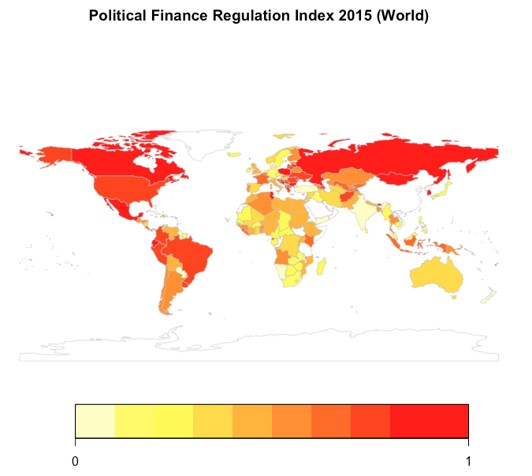Our results show an overall increase in Party Finance Regulation in most of the countries in the world. Figure z shows the time series plot of the PFR Index displays an increasing trend in the regulation effort in all regions. The slope of the time series remains slightly positive for the period 1996-2005, increasing its steepness after year 2006. Europe is the region that increased its party finance regulation the most, implementing 55% of regulations. The Americas and Asia are the second and third place among the regions who have implemented regulations the most.

#### Graph Nº Z. PFR Index times series by regions, 1996-2015: America, Europa, Africa, Oceania, Asia

Figure z shows an increasing trend in party finance regulation around the globe. On the other hand, the average Control of corruption shows a downward trajectory. The evolution of both time series shows that the increased in law effort made by different countries around the globe, is not associated with an overall improvement in the control of corruption.

#### Graph Nº z PFR and WB Control of Corruption Index time series, 1996-2015

This graph shows that the regulation area, which has increased the most in all regions, is Oversight and sanctions. All the sub indexes have increased systematically in the time span, this reflects a widespread trend around the globe to increase party finance regulation in a comprehensive manner, that addresses the whole range of regulation.

#### 

#### Graph Nº z. PFR Sub-index level in 1996 and 2015 by region. BLPI: Bans and limits on private income, PF: Public funding, RS: Regulation on spending, OS: Oversight and sanctions.

## Political Finance Regulation and Control of Corruption in Latin America

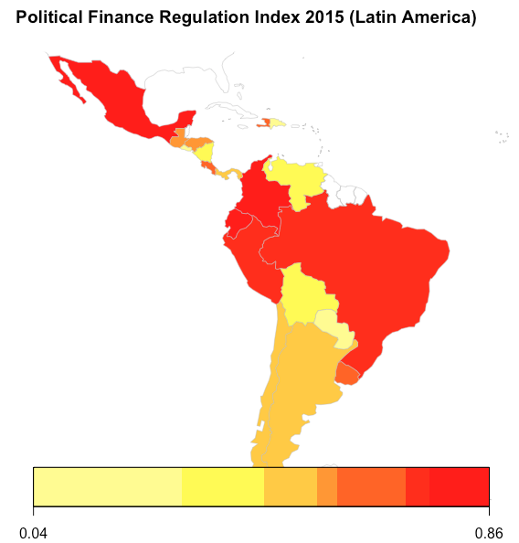

This graph shows the evolution for the Party Finance regulation Index and its subcomponents for Latin America. The regulation category that increased the most is oversight and sanctions. The next category that increased the most is regulation on spending. Then bans and limits on private income and finally Public Funding.

#### PFR Sub-index time series in 1996 and 2015 for Latin America. BLPI: Bans and limits on private income, PF: Public funding, RS: Regulation on spending, OS: Oversight and sanctions

The figure shows the evolution for the PFR Index for the Latin American countries included in the sample. Ecuador is the country that increased the most its party finance regulation, followed by Mexico and Colombia. Paraguay and Dominican Republic showed no increase in their levels of regulation.

#### Graph Nº z. PFR Index level in 2006 and 2015, Latin America

This graph shows the change in the level of party finance regulation for the Latin American countries included in the analysis. The countries that increased most their regulation between 2006 and 2015 are Ecuador, Mexico and Colombia. As shown in the next figure, increases in legislation are not always correlated with a reduction in the control of corruption, among the aforementioned countries; only Ecuador has shown an improvement in its level of corruption for the period 2006-2015. In addition, Guatemala, Honduras and Uruguay also have shown improvements on their levels of corruption in the last decade. Evidence of this trend is also shown in figure; while the Control of Corruption slightly improves for the period 1996-2010 in Latin America, this is reversed after year 2011 with a strong deterioration of the levels of corruption onwards.

#### Graph Nº z. PFR Index and World Bank Control of Corruption change in 2006-2015, Latin America

#### Graph Nº z. Mean PFR Index and World Bank Control of Corruption time series in 2006-2015, Latin America

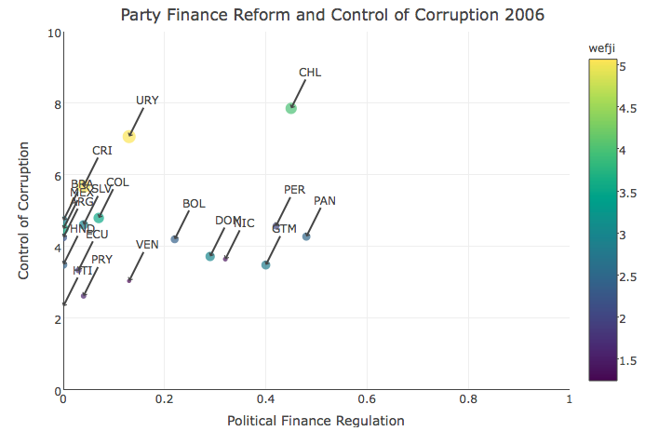

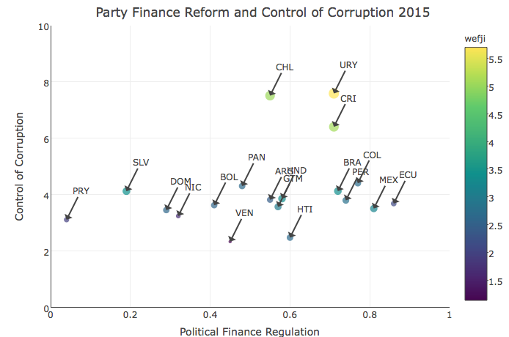

## Panel regression model of Latin America

### Variable description

*Dependent Variable:* World Bank Control of Corruption (CoC).

*Independent Variable:* Party Finance Regulation Index (PFR). ECLAC Capital Expenditures (PI). World Economic Forum Independence of the judiciary (JI).

*Control Variables:* Rural population (RP), Life expectancy (LE)

### Simple regression model

Table Nºz shows the simple regression model output for the main explanatory variables in our model, where Control of corruption is the main dependent variable. In this, equation (1) to (9) are estimated using OLS, Fixed effects (FE) and Random effects (RE). Party finance regulation seems to have a positive a significant effect on the control of corruption in a pooled OLS model. Interestingly, this result is reversed when accounting for the idiosyncratic characteristics of each country in panel estimations. Public investment and Judicial independence both have the expected signs. Thus, an increase in the level of public investment is associated with deterioration in the control of corruption; on the other hand, increases in judicial independence are correlated with improvements in the dependent variable. Both regressors are statistical significant at usual levels of confidence.

$$CoC_{ij}=β_{0}+β_{1}(PFR_{ij})+ϵ_{ij}$$

$$CoC_{ij}=β_{0}+β_{1}\left({PI}_{ij}\right)+ϵ_{ij}$$

$$CoC_{ij}=β_{0}+β_{1}({IJ}_{ij})+ϵ_{ij}$$

#### 

|  |  |  |  |  |  |  |  |  |  |
| --- | --- | --- | --- | --- | --- | --- | --- | --- | --- |
|  | OLS | FE | RE | OLS | FE | RE | OLS | FE | RE |
|  | (1) | (2) | (3) | (4) | (5) | (6) | (7) | (8) | (9) |
|  |  |  |  |  |  |  |  |  |  |
| PFR | 0.750*** | -0.0649 | -0.0601 |  |  |  |  |  |  |
|  | (0.205) | (0.0491) | (0.0494) |  |  |  |  |  |  |
| PI |  |  |  | -0.265 | -0.496** | -0.49** |  |  |  |
|  |  |  |  | (0.503) | (0.230) | (0.228) |  |  |  |
| JI |  |  |  |  |  |  | 0.546*** | 0.0608** | 0.151*** |
|  |  |  |  |  |  |  | (0.0229) | (0.0300) | (0.0310) |
| Cons. | -0.63*** | -0.27*** | -0.277* | -0.27*** | -0.25*** | -0.264 | -1.96*** | -0.48*** | -0.76*** |
|  | (0.103) | (0.0232) | (0.158) | (0.0637) | (0.0190) | (0.171) | (0.0741) | (0.0918) | (0.124) |
|  |  |  |  |  |  |  |  |  |  |
| Obs. | 180 | 180 | 180 | 178 | 178 | 178 | 179 | 179 | 179 |
| R-sq. | 0.070 | 0.011 |  | 0.002 | 0.028 |  | 0.763 | 0.025 |  |
| N |  | 18 | 18 |  | 18 | 18 |  | 18 | 18 |

Standard errors in parentheses

*** p<0.01, ** p<0.05, * p<0.1

#### Table Nºz Simple regression model

### Multivariate regression model

Multivariate regression model is estimated in equations (1) to (9) based on a equilibrium model setting. Results for pooled OLS, Fixed effects (FE) and Random effects (RE) are presented. Several estimation results are presented in order to test for the robustness of our analysis.

The regression model for equations (1) to (3):

$$CoC_{ij}=β_{0}+β_{1}\left(PFR_{ij}\right)+β_{2}\left(PI_{ij}\right)+β_{3}\left({JI}_{ij}\right)+ϵ_{ij}$$

The regression model for equations (4) to (6):

$$CoC_{ij}=β_{0}+β_{1}\left(PFR_{ij}\right)+β_{2}\left(PI_{ij}\right)+β_{3}\left({JI}_{ij}\right)+β_{4}(PFR_{ij})(JI_{ij})+β_{5}(PI_{ij})(JI_{ij})+ϵ_{ij}$$

The regression model for equations (7) to (9). Results for OLS, FE and RE are presented:

$$CoC_{ij}=β_{0}+β_{1}\left(PFR_{ij}\right)+β_{2}\left(PI_{ij}\right)+β_{3}\left({JI}_{ij}\right)+β_{4}\left(PFR_{ij}\right)\left(JI_{ij}\right)+β_{5}\left(PI_{ij}\right)\left(JI_{ij}\right)+RP_{ij}+LE_{ij}+ϵ_{ij}$$

The results in the equilibrium model show that Party finance regulation increases are related with deterioration in the control of corruption for Latin America. This relationship is statistically significant in the panel estimations.

The negative relationship between regulation and control of corruption is reverted for countries that show high levels of judicial independence in the sample. The interactions among these variables in the regression model, as well as the marginal effects plot in figure Nºz show this relationship. Thus, for countries with high levels of Judicial independence the increase in regulations have a positive effect on the control of corruption.

|  |  |  |  |  |  |  |  |  |  |
| --- | --- | --- | --- | --- | --- | --- | --- | --- | --- |
|  | OLS | FE | RE | OLS | FE | RE | OLS | **FE** | RE |
|  | (1) | (2) | (3) | (4) | (5) | (6) | (7) | **(8)** | (9) |
| **PFR** | -0.0601 | -0.0131 | -0.0078 | -0.81*** | -0.353** | -0.380** | -0.302 | **-0.309\*\*** | -0.320* |
|  | (0.121) | (0.0567) | (0.0625) | (0.306) | (0.150) | (0.164) | (0.241) | **(0.140)** | (0.170) |
| **PI** | -0.287 | -0.551** | -0.635** | -0.879 | -3.53*** | -3.31*** | -8.00*** | **-2.37\*\*** | -3.41*** |
|  | (0.268) | (0.271) | (0.287) | (1.208) | (0.984) | (1.057) | (1.105) | **(0.936)** | (1.100) |
| **JI** | 0.551*** | 0.0691** | 0.147*** | 0.419*** | -0.0299 | 0.0365 | 0.258*** | **0.0309** | 0.0971** |
|  | (0.0253) | (0.0300) | (0.0309) | (0.0545) | (0.0345) | (0.0366) | (0.0424) | **(0.0385)** | (0.0394) |
| **JI×PI** |  |  |  | 0.189 | 0.902*** | 0.819*** | 1.914*** | **0.673\*\*** | 0.844*** |
|  |  |  |  | (0.353) | (0.279) | (0.301) | (0.304) | **(0.262)** | (0.310) |
| **JI×PFR** |  |  |  | 0.258*** | 0.110*** | 0.119*** | 0.108 | **0.108\*\*\*** | 0.0969** |
|  |  |  |  | (0.0946) | (0.0413) | (0.0455) | (0.0729) | **(0.0393)** | (0.0471) |
| **LE** |  |  |  |  |  |  | 0.031*** | **-0.073\*\*** | -0.031* |
|  |  |  |  |  |  |  | (0.00810) | **(0.0239)** | (0.0178) |
| **RP** |  |  |  |  |  |  | -0.02*** | **-0.011** | -0.02*** |
|  |  |  |  |  |  |  | (0.00218) | **(0.0106)** | (0.00519) |
| **Cons** | -1.93*** | -0.45*** | -0.69*** | -1.56*** | -0.146 | -0.354** | -2.66*** | **5.378\*\*\*** | 2.351* |
|  | (0.0797) | (0.0911) | (0.125) | (0.156) | (0.106) | (0.141) | (0.613) | **(1.937)** | (1.349) |
|  |  |  |  |  |  |  |  |  |  |
| **Obs** | 177 | 177 | 177 | 177 | 177 | 177 | 160 | **160** | 160 |
| **R2** | 0.760 | 0.060 |  | 0.770 | 0.189 |  | 0.880 | **0.264** |  |
| **(n, T)** |  | (18, 10) | (18, 10) |  | (18, 10) | (18, 10) |  | **(18, 10)** | (18, 10) |

Standard errors in parentheses

*** p<0.01, ** p<0.05, * p<0.1

#### Estimation output: Equilibrium model

Aligned with equilibrium model theory, increases in the opportunities to corrupt, represented by the level in public investment, have a significant and negative effect in the control of corruption. This relationship is also reversed for countries with a high level of Judicial independence. Figure Nºz shows this relationship in the marginal effects plot

### Marginal effects

For the following specification:

$$CoC_{ij}=β_{0}+β_{1}\left(PFR_{ij}\right)+β_{2}\left(PI_{ij}\right)+β_{3}\left({JI}_{ij}\right)+β_{4}\left(PFR_{ij}\right)\left(JI_{ij}\right)+β_{5}\left(PI_{ij}\right)\left(JI_{ij}\right)+RP_{ij}+LE_{ij}+ϵ_{ij}$$

Marginal effects of PFR on control of corruption CoC for the interaction model:

$$\frac{dCoC_{ij}}{dPFR_{ij}}=β_{1}+β_{4}\left(JI_{ij}\right)=-0.3+0.18(JI_{ij})$$

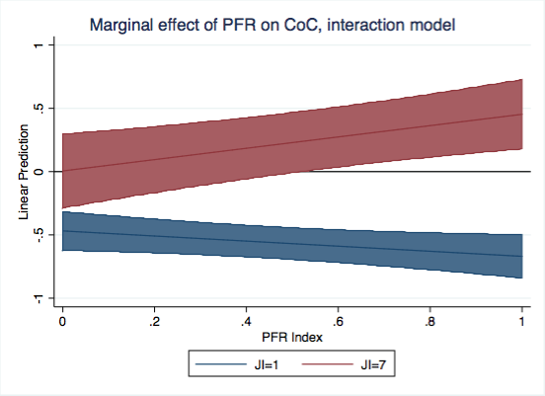

Marginal effects of PI on control of corruption CoC for the interaction model:

$$\frac{dCoC_{ij}}{dPFR_{ij}}=β_{2}+β_{5}\left(JI_{ij}\right)=-2.37+0.67(JI_{ij})$$

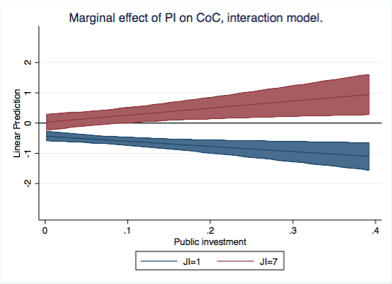

# References

Bértoa, Fernando Casal, Fransje Molenaar, Daniela R. Piccio, and Ekaterina R. Rashkova. 2014. “The World Upside down: Delegitimising Political Finance Regulation.” *International Political Science Review* 35(3): 355–75.

Blechinger, Verena. 2002. “Corruption and Political Parties.” *Sectoral Perspectives on Corruption* November.

Delavallade, Clara. 2006. “Corruption and Distribution of Public Spending in Developing Countries.” *Journal of Economics & Finance* 30(2): 222–39.

Della Porta, Donatella. 2004. “Political Parties and Corruption: Ten Hypotheses on Five Vicious Circles.” Crime, Law and Social Change 42(1): 35–60.

Fox, Jonathan. 1994. “The Difficult Transition from Clientelism to Citizenship: Lessons from Mexico.” World Politics 46(2): 151–84.

Heidenheimer, Arnold J. 1963. “Comparative Party Finance: Notes on Practices and Toward a Theory.” *The Journal of Politics* 25(4): 790.

Hopkin, Jonathan. 2004. “The Problem with Party Finance: Theoretical Perspectives on the Funding of Party Politics.” Party Politics 10(6): 627–51.

International Institute for Democracy and Electoral Assistance (IDEA). 2014. *Funding of Political Parties and Election Campaigns. A Handbook on Political Finance*. Sweden.

Karvonen, Lauri. 2007. “Legislation On Political Parties: A Global Comparison.” Party Politics 13(4): 437–55.

Mauro, Paolo. 1998. “Corruption and the Composition of Government Expenditure.” *Journal of Public Economics* 69: 263–79.

Mauro, Paolo. 1998. “Corruption: Causes, Consequences, and Agenda for Further Research.” *Finance and Development* 35(1): 11–14.

Mungiu-Pippidi, A. 2015. *The quest for good governance: how societies develop control of corruption*. Cambridge University Press.

Pierre, Jon, Lars Svåsand, and Anders Widfeldt. 2000. “State Subsidies to Political Parties: Confronting Rhetoric with Reality.” West European Politics 23(3): 1–24.

Pinto-Duschinsky, Michael. 2002. “Financing Politics: A Global View.” Journal of Democracy 13(4): 69–86.

Posada-Carbó, Eduardo. 2008. Kellogg Institute Working Papers Democracy, Parties and Political Finance in Latin America.

Scarrow, Susan E. 2004. “Explaining Political Finance Reforms Competition and Context.” *Party Politics* 10(6): 653–75.

Scarrow, Susan E. 2007. “Political Finance in Comparative Perspective.” *Annual Review of Political Science* 10(1): 193–210.

Tanzi, V., and H. Davoodi. 1997. “Corruption, Public Investment and Growth.” *IMF Working Papper*: 41.

Van Biezen, Ingrid. 2004. “Political Parties as Public Utilities.” Party Politics 10(6): 701–22.

Van Biezen, Ingrid, and Peter Kopecky. 2007. “The State and the Parties: Public Funding, Public Regulation and Rent-Seeking in Contemporary Democracies.” Party Politics 13(2): 235–54.

Wilcox, Clyde. 2001. *Transparency and Disclosure in Political Finance: Lessons from the United States Clyde*.